By: Noelle Moreland and Deana Podlenski
How to Dream Redirect without Dream Crushing
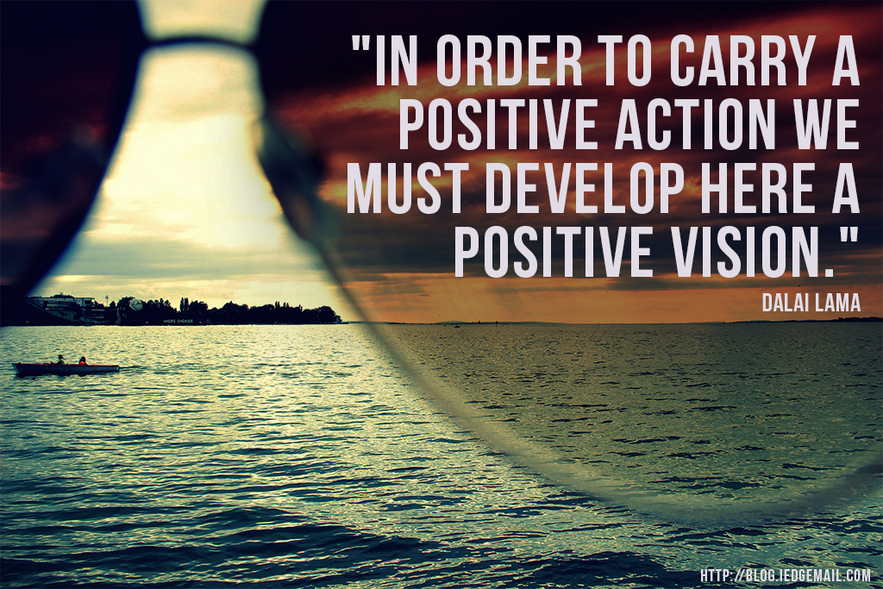

Notes

Career Resources
BLS – www.bls.gov -> Occupational Outlook Handbook
Job postings
Myers – Briggs – 16personalities.com
Free assessments online
Career assessments available at your college
Search majors offered at your university, or the university of interest

FORECLOSED STUDENT - A student who has decided on a major without research on career options and little comparison to own interests and strengths (Salinas & Ross, 2015)
ACADEMICALLY IDEALISTIC STUDENT – A student who has taken a course specifically needed to be successful in a major but has failed it (or did not earn the grade needed) multiple times but still insist on pursuing that major
DREAM REDIRECTING - The hard conversation advisors must have with the Academically Idealistic Student to discuss their current status/goals/motivation/plan and redirect their path towards success

Phrases to Use
- It is not about if you can do it, it’s if you will do it
- You say you have the commitment, but what are you willing to change
- You say that you can get those grades, but you have not done that in the past
Student says they will get all A’s next semester when they have been averaging B’s and C’s
- I recommend…
- My advice to you is…
- Previously what I have seen (based on student)
- In my experience as an advisor, this is what I see…

Dream Redirecting Method

Notes

Sources
Proyer, R., Gander, F., Wellenzohn, S., & Ruch, W. (2015). Strengths-based positive psychology interventions: A randomized placebo-controlled online trial on long-term effects for a signature strengths- vs. a lesser strengths-intervention.

Salinas, O. T., & Ross, K. W. (2015) Courageous conversations: Advising the foreclosed student. Retrieved from NACADA Clearing house of Academic Advising Resources Website

Schreiner, L.A. & Anderson, E. (2005). Strengths-based advising: a new lens for higher education. NACADA Journal, 25(2), p 20-29.

Vela, J. C., Lu, Ming-Tsan P., Lenz, A. S., Savage, M. C., & Guardiola, R. (2016). Positive Psychology and Mexican American College Students' Subjective Well-Being and Depression. Hispanic Journal of Behavioral Sciences, 38(3), 324-340.

Zolfagharifard, R. (2015). Growth-mindset vs. fixed-mindset. Positive Psychology Program website.

Identify the Student
- Poor academic performance
- Unhappy with choice
- Lack of motivation
Define
- Define the Students Strengths
  - What subjects do you enjoy studying the most?
  - What brings out your best? As you think of a time when you did something well, what were the ingredients of that success? What environment and kind of people bring out the best in you?
  - What fascinates you?
  - Tell me about a challenge you experienced that you have had to overcome. What did you do to overcome that challenge? How did you do it?
- Define Commitment
  - When have they been committed
  - What commitment looks like to the student
Awareness
- Affirm their strengths and increase their own awareness of strengths
  - Which of your strengths do you feel you rely on to be most successful?
  - Which of your strengths do you think will be most useful to you in succeeding academically? Relationally? In your career?
    - Depending on your role, you may stop at asking about academically
  - What strengths are most characteristic of you? Give an example of a time when you used one of those strengths.
- Commitment Awareness
  - Based on your actions, how committed would you say you are to your major?
  - Do your actions reflect your level of commitment you think you have?
Moving Forward
- Envision a future – goals and how their strengths can help reach them
  - What are you most looking forward to in college
    - Were you looking forward to? After not being successful they may be dreading college
  - Where do you want to be in five years
    - Make the student be specific, not just “graduated”
  - What strengths do you think are your biggest asset? What skills and knowledge do you need to add to that natural talent in order to develop it into consistently excellent performance?
- Commitment For the Future
  - Are you willing to put effort into building on your strengths and weaknesses for your chosen major/career?
Offer Follow Up

