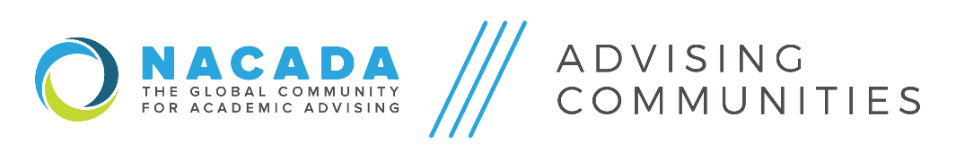
2019-2020 Steering Committee Members/Cluster Reps

Rebecca Hapes, Appointed Division Rep (2018-2020)  Texas A&M University  rhapes@tamu.edu // (979) 845-9733 | Amber Kargol, Elected Division Rep (2019-2021)  Iowa State University  akargol@iastate.edu // (515) 294-2553
Cluster 1  Wendy Schindler (2018-2020)  TBD  wkschindler@gmail.com // (314)-608-3443 | Cluster 2  Shelley Price-Williams (2019-2021)  Northern Illinois University  shelleypricewilliams@gmail.com //(618)-650-2914
Cluster 3  Teresa Brethauer (2018-2020)  Walden University  teresa.brethauer@mail.waldenu.edu // (443) 627-7284 | Cluster 4  Stephanie Kraft-Terry (2019-2021)  University of Hawaii – Manoa  kraft2@hawaii.edu // (808) 956-0735
Cluster 5  Stacy Outlaw (2019-2021)  Elon University  soutlaw@elon.edu // (336)-278-5975 | Cluster 6  John Sauter (2019-2021)  Niagara University  jps@niagara.edu // (716) 286-8062
Cluster 7  Wiona Porath (2019-2021)  Johns Hopkins University  wporath1@jhu.edu // (410) 516-7065 | Cluster 8  Vince Hernandez (2019-2021)  Texas A&M University  vhernandez@tamu.edu // (979) 845-3127
Cluster 9  Lindsey Byrd (2018-2020)  Pensacola State College  lbyrd@pensacolastate.edu // (850) 484-1633 | Dawn Krause  NACADA Executive Office Liaison  dawnkrause@ksu.edu // (785) 532-0941

Assignment of Clusters — Cluster Reps are assigned a specific cluster of communities, and serve in a support role as a point of contact with those groups in carrying out their responsibilities:

Cluster 1 - First-Generation College Students, Assessment of Advising, Education Majors, Appreciative Advising, LGBTQA Advising and Advocacy

Cluster 2 - Advising Graduate & Professional Students, Advising Students With Disabilities, Advising Administration, Orientation Advising, High School To College Advising
Cluster 3 - Career Advising, Canadian Advising, Advising Adult Learners, Faculty Advising, Undecided & Exploratory Students
Cluster 4 - Multicultural Concerns, Science, Technology, Engineering & Mathematics, Theory, Philosophy, & History, Advising Student Athletes
Cluster 5 - Advising Business Majors, HBCU Advising, Health Professions Advising, Peer Advising & Mentoring
Cluster 6 –Probation/Dismissal/ Reinstatement Issues, Technology in Advising, Advising Fine Arts Students, Transfer Students

Cluster 7 - Small Colleges & Universities, New Advising Professionals, Global Engagement, Advisor Training & Development
Cluster 8 - Liberal Arts, Two-Year Colleges, Advising High Achieving Students, Advising & Academic Coaching
Cluster 9 - Distance Advising for Online Education, Veterans, Military Students, and Family Members, First-Year Students,
Native American & Tribal Colleges

