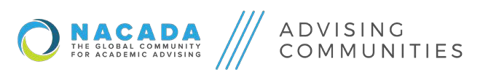

Division Unit Report for [INSERT COMMUNITY NAME] Submitted by [Chair’s Name]

Please complete Columns 1 through 6 and return by November 15, 2019.

Columns 7 and 8 are completed for the progress report due August 15, 2020. Please send your report to ACD Reps: Rebecca Hapes (rhapes@tamu.edu), Amber Kargol (akargol@iastate.edu) and EO Liaison Dawn Krause (dawnkrause@ksu.edu). Please copy your Cluster Rep as well. Thank you!

1. NACADA Strategic Goal(s)  (List one of NACADA’s 7  strategic goal(s) related to the specific desired outcome in #2) | 2. Specific desired outcome  (What you want to occur as a result of your efforts; what you want someone to know, do, or value) | 3. Actions, activities or opportunities for outcome to occur  (What processes need to be in place to achieve desired outcome) | 4. Outcome measurements & related data instrument(s)  (How will you specifically measure the outcome and with what instruments? e.g. survey, focus group) | 5. Other groups or individuals to connect  (List opportunities for collaboration with other groups) | 6. Anticipated challenges  (How will you address issues that arise as you work to achieve the outcome?) | 7. Progress toward  outcome  (Complete in August 2020 report) | 8. Future  action(s) based on data  (Data-informed decisions)  (Complete in August 2020 report)
INSERT rows as needed

Resources:
NACADA Strategic Goals - https://www.nacada.ksu.edu/About-Us/Vision-and-Mission.aspx
Advising Community Self-Assessment Rubric - https://docs.google.com/document/d/1QRd4FTxuE72NDOMdcw8cnDP7k5pISRZIYhYzG-EgP0o/edit?usp=sharing
Advising Community Chair Self-Assessment Rubric - https://docs.google.com/document/d/1Z-4O7ir_AzjM088vGNOsC5odtYOEMbNAYYseEUU6U88/edit?usp=sharing

